Hampden Football Stadium

Hampden Football Stadium is the home to Scotland’s National Football Team and also Queens Park Football Club. Its located in the middle of Glasgow in an area called Mount Florida. It has a capacity of 51 thousand seats. It was opened in 1903 it was done up in 1999 and now it is fully seated. It is also the oldest Football Stadium in the world. Its 117 years old.
Hampden park was named after a soldier called John Hampden also there is a row of houses next to Hampden called Hampden too.

FOOTBALL
The first game ever game played at Hampden park was Queens Park vs Celtic on 31st of October 1903 , Queens Park won the game 1-0.
This Photo by Unknown Author is licensed under CC BY
Scotland National Team played their first game at Hampden in 1906.
This Photo by Unknown Author is licensed under CC BY
The first ever woman to score at the Betfred Cup Final in Hampden was my Auntie Sharon, on the 8th December 2019.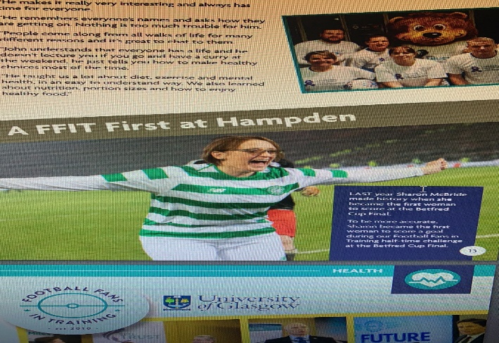
This Photo by Unknown Author is licensed under CC BY
Hampden began to hold the Scottish League Cup Final in 1947.
This Photo by Unknown Author is licensed under CC BY

Hampden Park hold two World Records. The first record was on the 17th of April 1937 it was the first all ticketed Scotland match. The match had 149,415 people there, which is a British record. The second record was from the Scottish cup final it had 146,433 people there , which is a European record.
This Photo by Unknown Author is licensed under CC BY

UEFA CHAMPIONS LEAGUE
Hampden has hosted six European finals. In 2002 the UEFA Champions league final.
This Photo by Unknown Author is licensed under CC BY
On the 15th of May 2002, the UEFA Champions League final was held at Hampden when real Madrid beat Bayern Leverkusen 2-1 to win the Champions league final.
This Photo by Unknown Author is licensed under CC BY

Commonwealth Games
This Photo by Unknown Author is licensed under CC BY-SA
In 2014 Hampden Football Stadium hosted the Commonwealth Games. The competition took place between the 27th July and the 2nd August. A track was built around the football pitch. The Track and Field Athletics competitions were held there. It had a warm up track and jump areas.
This Photo by Unknown Author is licensed under CC BY-SA

Tours and Museum 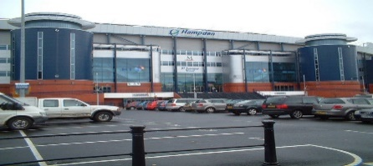
This Photo by Unknown Author is licensed under CC BY-SA
The Hampden Stadium Tour allows you to experience Hampden park the way the players do on a match day. You get to visit the underground roadway, the team changing rooms and you can strike a ball in the Hampden hot shot gallery. The hot shot gallery measures how far your shot goes and how fast it goes. You get to walk down the tunnel and hear the famous Hampden Roar. Hampden is where The Scottish Football Museum is. The Scottish Cup is kept here. It is the world’s oldest national trophy. You can also visit the Scottish Football Hall of Fame, it shows all of Scotland’s greatest players.

The Hampden Roar
The Hampden Roar was born from Scotland’s noisy fans in the 1920’s. Two players who both scored against England have been thanked for getting thousands of scots screaming “GIT IT UP YE”. The players were called Alex Cheyne who played for Aberdeen and the other was Celtics Jimmy McGrory.

Entertainment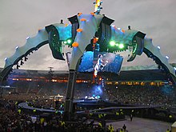

Hampden does not just host football games. There has also been lots of music concerts held there too such as Pink, Ed Sheeran, Robbie Williams, EMINEM, Coldplay and Oasis.

