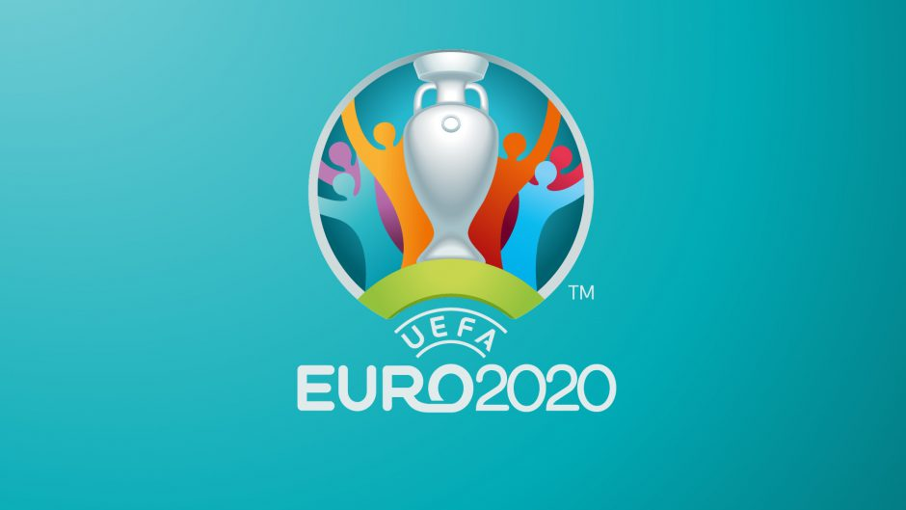

Glasgow
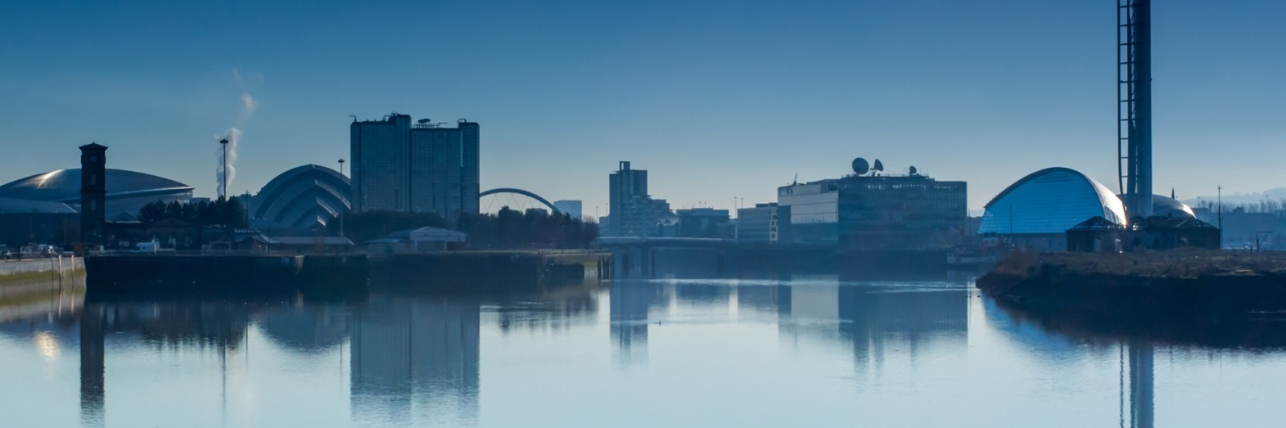
UEFA Euro 2020 Host

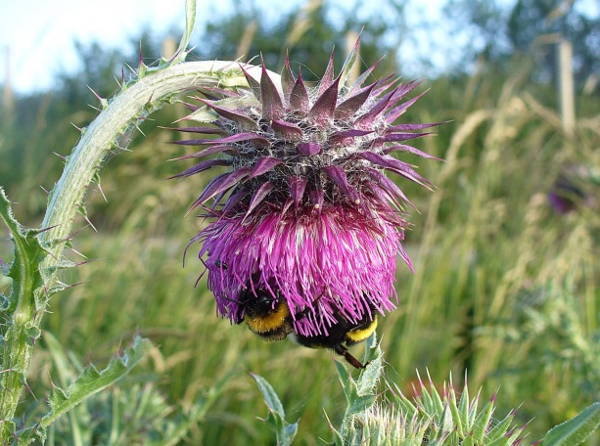
A guide to the city.

Glasgow is the place to be!!

If you are traveling to Glasgow to watch the EUROS 2020, then this leaflet will make your time at Glasgow be amazing.

CONTENTS:
- Page 1: A bit about Glasgow.
- Page 2: Glasgow football.
- Page 3:Famous buildings to visit.
- Page 4:Yummy food!

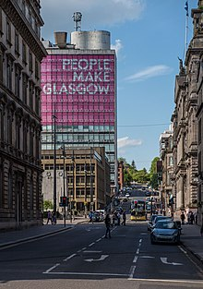
A bit about Glasgow.

‘People make Glasgow’ is Glasgow’s slogan. This is what we use to make Glasgow sound like a good place to be because of the people that live there.
1,673,000 people live in Glasgow.
If you walk through the streets of Glasgow you will see lots of amazing art work on the side of buildings, these are by done artist that live in Glasgow. Below is an example of one of the pictures you could go and see.

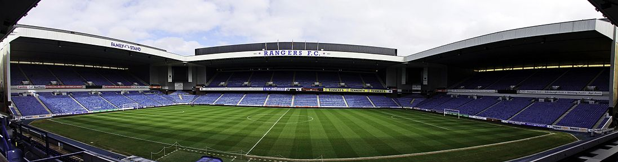

Glasgow Football
Glasgow is home to four football teams.
- Patrick Thistle at Firhill Stadium.
- Queens Park at Hampden Park.
- Celtic at Celtic Park.
- Rangers at Ibrox.
The most famous competition is between Celtic and Rangers.
Their fans get very excited for every game and are proud to be fans of their team.
You can visit the football stadiums and do a tour of the grounds. This will allow you to see the football pitch, the mascot and go to the visitor shop where you can buy things with the teams badge on.
But of course he main attraction for being in Glasgow is to watch the UEFA EURO 2020 game!!
You can watch this game at Hampden but this will all depend on the COVID-19 restrictions.

Famous buildings
If you like to visit beautiful buildings then you can’t miss out any of these!
- Kelvingrove Art Museum – is where you can see lots of beautiful art, learn about Ancient Egypt and more.
- Glasgow Science Centre-you can learn about cool science experiments.
- George Square-has a lot of great places to eat.
- The hydro-is where lots of different events happen and it’s lit up with cool lights at night.

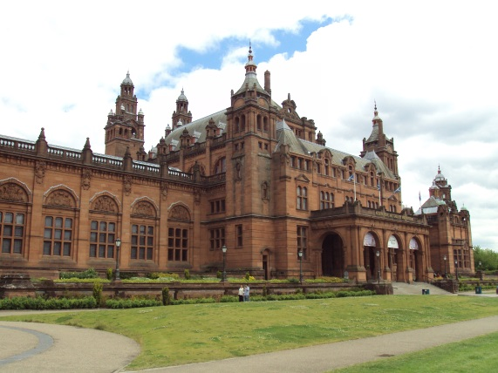
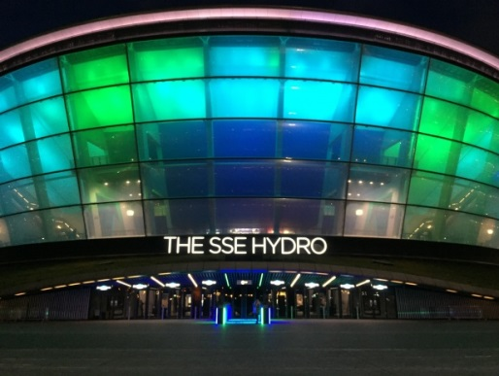

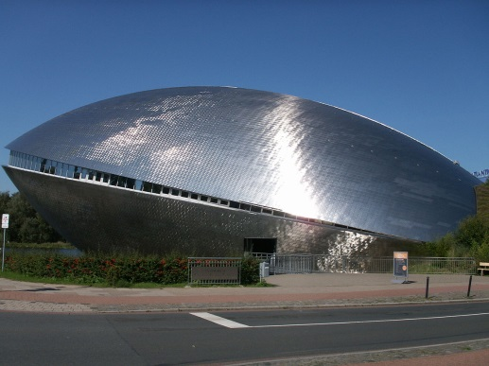
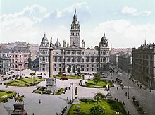

Yummy Food
In Glasgow there are lots of different places to eat and lots of yummy food.
If you’re in a rush you can have fast food at McDonald’s, KFC, Burger King and much more.

Or you can go to a fancy restaurant and eat Italian, Mexican etc.
Although all of these types of food are available, the most common type to eat is British food.

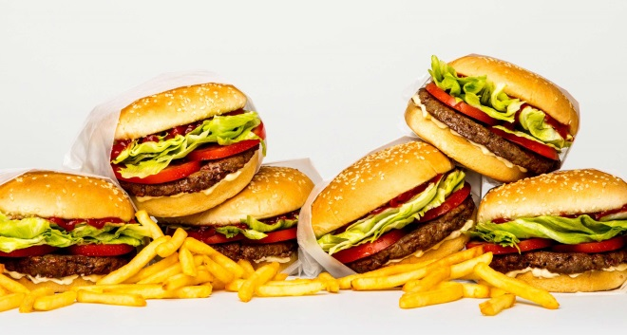
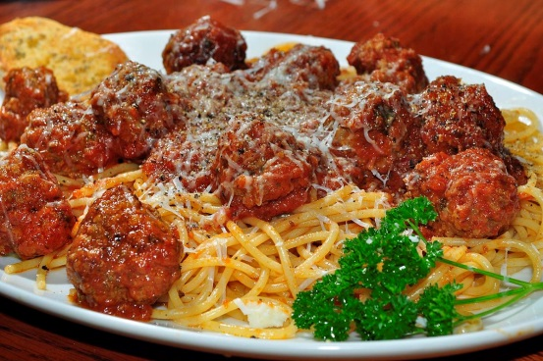

Sources of information

Google
Peopemakeglasgow.com
Glasgowlife.org.uk
Tripadvisor.co.uk

